Information Dissemination in the Grid Environment – Extended Specifications

Status of This Memo
This memo provides a recommendation to the Grid communities. The intention is to define a standard. Distribution is unlimited.
Copyright Notice
Copyright © Open Grid Forum (2004-2007). All Rights Reserved
Abstract
INFOD (Information Dissemination) provides a general means to determine which messages are to be sent from which Subscribers to which consumers based upon information kept in a registry. The extended functionality adds – will be specific once we are done

This is a very early draft
Last update started on
At
09:44:55

Table of Contents
Table of Contents 2
1 Introduction 3
1.1 The Registry 4
1.1.1 Additional REPLACE Operations 4
1.1.2 Update Operation 5
1.1.3 Association of Data Sources to Secondary Publishers 5
1.1.4 Association between Publishers and Data Sources 5
1.1.5 Associations between Consumers 6
1.1.6 Policies for the Delivery of Messages 6
1.1.7 Operational Characteristics 6
1.1.8 Streaming (Optional) 7
1.1.9 Subscription to Registries 7
1.1.10 Distributed Registries 7
1.1.11 Additional Things to Consider 7
1.1.11.1 Lineage of Property Information 7
1.1.11.2 Security Constraints for Data Sources 7
1.2 Summary of key aspects of INFOD 7
1.3 Glossary 7
1.4 Terminology 7
1.5 Namespaces 8
1.6 Fault Definitions 9
2 The Extended INFOD Registry Interface 10
3 INFOD Notification and Streaming Interfaces 11
4 Security Considerations 12
5 Appendix I – XML Schema 13
6 Appendix II – WSDL 1.1 14
7 Author Information 15
8 Intellectual Property Statement 16
9 Full Copyright Notice 17
10 Questions/Things to do 18

Introduction
Note: During the current phase of the work on the Extended Specification all information is gathered in this chapter. During a later phase, the information will be formalized and most of it will be moved to the appropriate chapters.
The abstract of the INFOD Base Specifications states:
INFOD (Information Dissemination) provides a general means to determine which messages are to be sent from which publishers to which consumers based upon information kept in a registry. To support this, INFOD specifies interfaces that allow the characterization (in the registry) of publishers, consumers and various other components using vocabularies that are meaningful to members of the communities they belong to. INFOD makes use of a notify operation similar to that defined by the WS-Notification specification to send information between publishers and consumers.
The following additional requirements have been identified:
- Additional REPLACE operations: The Replace operation will be added for property vocabulary instances and data sources.
- UPDATE operation: An UPDATE operation will be added for those resources for which a REPLACE is specified. The REPLACE operation is a special case of the UPDATE operation.
- Association of data sources to secondary publishers: Secondary publishers are intended to provide an integrated view of information in data sources associated to various publishers.
- Association between publishers and data sources: Publishers may direct other publishers to disseminate information on behalf of them. The association can be done for all data sources belonging to a publisher or per data sources
- Association between consumers: Consumers may direct other consumers to receive messages on behalf of them. Consumers receiving messages are called recipients.
- Policies for the delivery of messages: Consumers can specify when and how messages are delivered to them.
- Operational characteristics of entries: A set of operational characteristics can be specified for various entries.
- Notification with streaming (optional): Publishers may send messages to consumers in streaming mode to increase the throughput of the dissemination.
- Subscriptions to Registry: The registry will support subscriptions. Since there is no agreed upon streaming language the registry will inform the consumers whenever a solution set has changed.
- Distributed Registries: Disseminators may have their own local registry. These registries may share selected information through notification.
- Additional things to consider:
- Lineage of property information: to be added
- Security constraints for Data Sources:
Figure 1: INFOD Resources captures the extended INFO model.
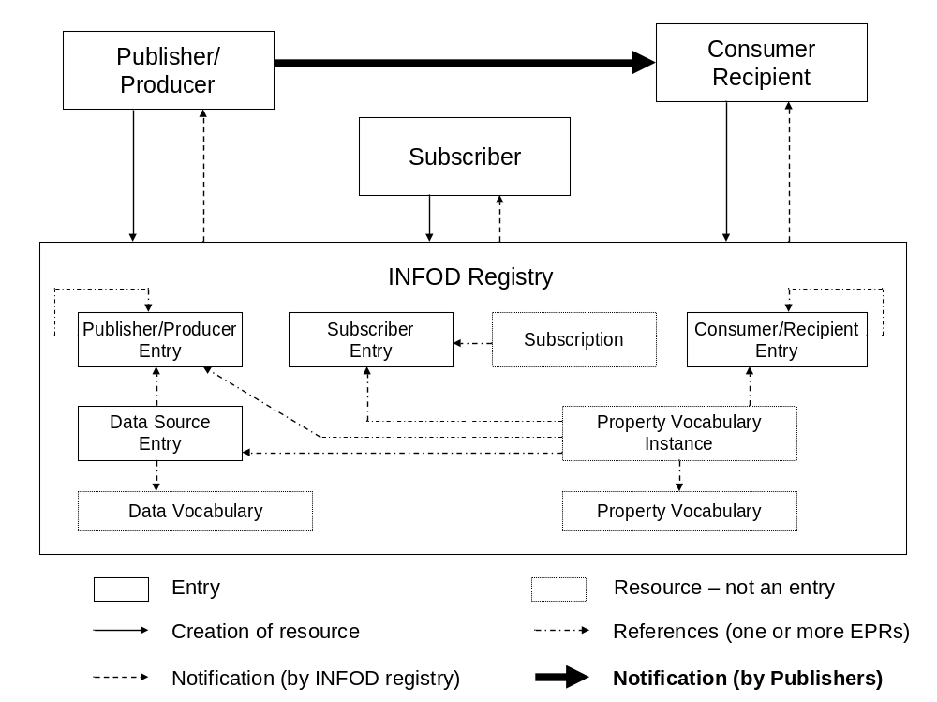
Figure 1: INFOD Resources
The impact of these extensions on the registry will be discussed in the next section.

The Registry

Additional REPLACE Operations
Property vocabulary instances and data sources can be replaced.
- ReplacePropertyVocabularyInstance
- ReplaceDataSource
The list may be extended for new resource types.
The syntax will follow the pattern for the existing REPLACE commands.

Update Operation
Resources that can be replaced can now also be updated. The update syntax and semantics follows the recommended XML standard. REPLACE is a special case of UPDATE.
- UpdatePublisherEntry
- UpdateSubscriberEntry
- UpdateConsumerEntry
- UpdateSubscription
- UpdatePropertyVocabularyInstance
- UpdateDataSource
The list may be extended for new resource types.
The use of the UPDATE operation allows references to resource marked as ‘DISABLE NEW’ to remain valid.

Association of Data Sources to Secondary Publishers
In the base support data sources are associated to a single publisher, called the primary publisher. The extended support, optionally, allows the association of secondary publishers to a data source.
Secondary publishers are intended to integrate information from several publishers.
The INFOD registry will only consider secondary publishers if multiple data sources are referenced and there are no primary publishers associated to all of them.

Association between Publishers and Data Sources
Producers may decide to outsource the dissemination of information of some or all of their data sources to other publishers. This can be done by creating an association between two publishers – details to be determined.
This association can also be done with a finer granularity; e.g., a data sources would have three entries for publishers:
This would lead to the following specifications related to a data source:
- The owner or producer of – optional, primary publisher is producer if not specified
- The primary publisher of a data source – this is the base model
- The secondary publishers – optional for
The association allows building simple publishers that are ‘only’ producers.

Associations between Consumers
Note: It is not yet clear if this is needed or if the functionality in the Base Specification is sufficient
Messages are delivered to entries called recipients. In the Base Specification all consumers act as their own recipient. The Extended Specifications allow consumers to identify other consumers who could act as their recipient. There will be one primary recipient and optionally one or more secondary recipients. By default, a consumer is its own primary recipient.
This association allows consumers to be mostly focused on the processing of incoming messages and outsource the interaction with consumers to recipient.

Policies for the Delivery of Messages
Consumers can determine when messages can be delivered, based on date of time, publisher (producer) and message content. Furthermore, which recipient has to be used for which criteria? Recipients can be directed to filter, enrich, forward. And distribute messages.

Operational Characteristics
Publishers and consumers can specify a set of operational characteristics.
Candidates are:
- Retention time and query support
- At least once/at most once/exactly once delivery
- *** more to come

Streaming (Optional)
Streaming should be used to deal with the notification between publishers and consumers experiencing high message traffic.
Existing technology will be used – tbd.

Subscription to Registries
INFOD registries support subscription. Since there is no standard yet for a streaming language, standard XQuery will be used. The semantics will be that a subscriber to the INFOD registry will be informed if the solution of the XQuery has changed.
This is consistent with the registry notification of the Base Specifications.

Distributed Registries
INFOD Registries can cooperate and share information.
Existing technology will be used – tbd.

Additional Things to Consider

Lineage of Property Information

Security Constraints for Data Sources

Summary of key aspects of INFOD
The INFOD extended specification may be summarized:

Glossary
Primary publisher A publisher defined as a primary publisher in a data source.
Producer A producer is the owner of a data source.
Secondary publisher A publisher defined as a secondary publisher in a data source.

Terminology
Except in this introductory chapter, the keywords "MUST", "MUST NOT", "REQUIRED", "SHALL", "SHALL NOT", "SHOULD", "SHOULD NOT", "RECOMMENDED", "MAY", and "OPTIONAL" in this document are to be interpreted as described in [IETF RFC 2119].
When describing abstract data models, this specification uses the notational convention used by the “XML Information Set” (see http://www.w3.org/TR/xml-infoset/). Specifically, abstract property names always appear in square brackets (e.g., [some property]).
This specification uses a notational convention, referred to as “Pseudo-schemas”. A Pseudo-schema uses a BNF-style convention to describe attributes and elements:
- `?' denotes optionality (i.e. zero or one occurrences),
- `*' denotes zero or more occurrences,
- `+' one or more occurrences,
- `[' and `]' are used to form groups,
- `|' represents choice.
- Attributes are conventionally assigned a value which corresponds to their type, as defined in the normative schema.
- Elements with simple content are conventionally assigned a value which corresponds to the type of their content, as defined in the normative schema.
- The use of {any} indicates the presence of an element wildcard (<xs:any/>).
- The use of @{any} indicates the presence of an attribute wildcard (<xs:anyAttribute/>).
- In the interest of brevity, some extensibility points have been omitted from the Pseudo-schemas.

<!-sample pseudo-schema -->
<element
required_attribute_of_type_QName="xs:QName"
optional_attribute_of_type_string="xs:string"? >
<required_element />
<optional_element /> ?
<one_or_more_of_these_elements /> +
[ <choice_1 /> | <choice_2 /> ] *
</element>

Where there is disagreement between the separate XML schema and WSDL files describing the messages defined by this specification and the normative descriptive text (excluding any pseudo-schema) in this document, the normative descriptive text will take precedence over the separate files. The separate files take precedence over any pseudo-schema and over any schema and WSDL included in the appendices.

Namespaces
The following namespaces are used in this document:
Prefix | Namespace | Meaning
S | http://schemas.xmlsoap.org/soap/envelope/ OR http://www.w3.org/2003/05/soap-envelope | SOAP Envelope
xsd | http://www.w3.org/2001/XMLSchema | XML Schema
wsa | http://www.w3.org/2005/08/addressing | WS-Addressing
wsrf-bf | http://docs.oasis-open.org/wsrf/bf-2 | WS Base Faults
wsnt | http://docs.oasis-open.org/wsn/b-2 | WS-Base Notification
wsntw | http://docs.oasis-open.org/wsn/bw-2 | WS-Base Notification
wstop | http://docs.oasis-open.org/wsn/t-1 | WS-Topics
infod | http://www.ogf.org/infod | INFOD
The INFOD name space is divided into two subcomponents (INFODRegistry and INFODNotify)

Fault Definitions
All faults generated by a NotificationProducer or SubscriptionManager should be compliant with the WS-BaseFaults (see http://docs.oasis-open.org/wsrf/wsrf-ws_base_faults-1.2-spec-os.pdf) specification.
All faults defined by this specification MUST use the following URI for the WS-Addressing [action]:
http://www.ogf.org/infod/fault.

The Extended INFOD Registry Interface

INFOD Notification and Streaming Interfaces

Security Considerations
To be added

Appendix I – XML Schema
To be added

Appendix II – WSDL 1.1
To be added

Author Information
Vijay Dialani
IBM Corporation
Almaden Research Center
650 Harry Road,
San Jose, CA 95120-6099
USA

Ronny Fehling
Oracle Corporation
600 Blvd. de Maisonneuve Ouest
Montreal
Quebec H3A 3J2
Canada

Steve Fisher
Rutherford Appleton Laboratory
Chilton
Didcot
Oxon
OX11 0QX
UK

Dieter Gawlick
Oracle Corporation
500 Oracle Parkway
Redwood Shores
CA 94065
USA

Raghul Gunasekaran
University Tennessee, Knoxville
1508 Middle Drive
Knoxville, TN 37996-2100
USA

Christopher Kantarjiev
Oracle Corporation
500 Oracle Parkway
Redwood Shores
CA 94065
USA

Mallikarjun Shankar
Oak Ridge National Laboratory
Oak Ridge
TN 37831
USA

Intellectual Property Statement
The OGF takes no position regarding the validity or scope of any intellectual property or other rights that might be claimed to pertain to the implementation or use of the technology described inthis document or the extent to which any license under such rights might or might not be available; neither does it represent that it has made any effort to identify any such rights. Copies of claims of rights made available for publication and any assurances of licenses to be made available, or the result of an attempt made to obtain a general license or permission for the use of such proprietary rights by implementers or users of this specification can be obtained from the OGF Secretariat.
The GGF invites any interested party to bring to its attention any copyrights, patents or patent applications, or other proprietary rights which may cover technology that may be required to practice this recommendation. Please address the information to the OGF Executive Director.

Full Copyright Notice
Copyright (C) Open Grid Forum (2004-2007). All Rights Reserved.
This document and translations of it may be copied and furnished to others, and derivative works that comment on or otherwise explain it or assist in its implementation may be prepared, copied, published and distributed, in whole or in part, without restriction of any kind, provided that the above copyright notice and this paragraph are included on all such copies and derivative works. However, this document itself may not be modified in any way, such as by removing the copyright notice or references to the OGF or other organizations, except as needed for the purpose of developing Grid Recommendations in which case the procedures for copyrights defined in the OGF Document process must be followed, or as required to translate it into languages other than English.
The limited permissions granted above are perpetual and will not be revoked by the OGF or its successors or assignees.

Questions/Things to do
- Check for ???
- If there are small extendion to the Base Interface are we going to write every thing from scratch; e.g., Subscribers can now reference constrints associated to disseminators, property instances can be associated to disseminators

Information Dissemination in the Grid Environment (see http://forge.gridforum.org/sf/go/doc13627?nav=1)
One could also/instead add an association between different publishers, coming close to the notion of disseminator
The term recipient needs to be replaced by a more meaningful term. This model comes close to the notion of POBoxes. The only difference is hat there is no additional entry type.
XQuery Update Facility (see http://www.w3.org/TR/2006/WD-xqupdate-20060711/)
This standard is expected to be approved before the extended specifications are finished.

